**Table 4.1** Survey sites

GBR Section Zone Reef Site Latitude (S) Longitude (E) Site code

|  |  |  |  |  |  |
| --- | --- | --- | --- | --- | --- |
| Cape York Out of GBRMPA | Dugong | Dugong site 1 | 10.5240 | 143.1178 | 1052_1 |
| Out of GBRMPA | Dugong | Dugong site 2 | 10.5315 | 143.1139 | 1052_2 |
| Out of GBRMPA | Bayag | Bayag site 1 | 10.5685 | 143.2455 | 1056_1 |
| Out of GBRMPA | Bayag | Bayag site 2 | 10.5686 | 143.2536 | 1056_2 |
| Lockhart River blue | Burke | Burke site 1 | 12.6464 | 143.5608 | 1264_1 |
| blue | Zenith | Zenith site 2 | 12.7644 | 143.6064 | 1276_2 |
| blue | Zenith | Zenith site 1 | 12.7694 | 143.6023 | 1276_1 |
| Cape Melville blue | 13-122 | 13-122 site 1 | 13.8989 | 144.0175 | 1389_1 |
| green | Corbett | Corbett site 1 | 14.0043 | 144.1402 | 1400_1 |
| green | Switzer | Switzer site 1 | 14.3451 | 144.7435 | 1434_1 |
| green | Switzer | Switzer site 2 | 14.3459 | 144.7460 | 1434_2 |
| green | Switzer | Switzer site 3 | 14.3700 | 144.7757 | 1434_3 |
| blue | Mid | Mid site 2 | 14.4496 | 144.9763 | 1444_2 |
| blue | Mid | Mid site 1 | 14.4564 | 144.9893 | 1444_1 |
| Cooktown blue | Martin | Martin site 2 | 14.7537 | 145.3584 | 1475_2 |
| blue | Martin | Martin site 1 | 14.7542 | 145.3617 | 1475_1 |
| blue | Rocky Isles B | Rocky Isles B site 1 | 14.8713 | 145.5351 | 1487_1 |
| blue | Rocky Isles B | Rocky Isles B site 2 | 14.8774 | 145.5302 | 1487_2 |
| blue | 15-043 | 15-043 site 2 | 15.4499 | 145.5199 | 1544_2 |
| blue | 15-043 | 15-043 site 1 | 15.4533 | 145.5087 | 1544_1 |
| green | Evening | Evening site 1 | 15.8996 | 145.6638 | 1589_1 |
| blue | Morning | Morning site 1 | 15.9570 | 145.6976 | 1595_1 |
| blue | Morning | Morning site 2 | 15.9608 | 145.6945 | 1595_2 |
| Cairns blue | Batt | Batt site 1 | 16.3730 | 145.6962 | 1637_1 |
| green | Michaelmas | Michaelmas site 1 | 16.5572 | 145.9992 | 1655_1 |
| green | Scott | Scott site 1 | 17.0598 | 146.1883 | 1705_1 |
| blue | Peart | Peart site 1 | 17.4679 | 146.4053 | 1746_1 |
| blue | Peart | Peart site 2 | 17.4706 | 146.4070 | 1746_2 |
| Townsville blue | Otter | Otter site 2 | 18.0804 | 146.5832 | 1808_2 |
| blue | Otter | Otter site 1 | 18.0836 | 146.5722 | 1808_1 |
| blue | Bramble | Bramble site 2 | 18.4372 | 146.7490 | 1843_2 |
| blue | Bramble | Bramble site 1 | 18.4478 | 146.7251 | 1843_1 |
| Mackay & blue | Darley | Darley site 2 | 19.2395 | 148.1402 | 1923_2 |
| Bowen blue | Darley | Darley site 1 | 19.2401 | 148.1459 | 1923_1 |
| blue | Block | Block site 2 | 19.8007 | 149.4195 | 1980_2 |
| blue | Block | Block site 1 | 19.8075 | 149.4176 | 1980_1 |
| blue | Little Stevens | Little Stevens site 2 | 20.5897 | 150.0172 | 2058_2 |
| blue | Little Stevens | Little Stevens site 1 | 20.5948 | 150.0178 | 2058_1 |
| blue | Paul | Paul site 2 | 21.3117 | 150.7091 | 2131_2 |
| blue | Paul | Paul site 1 | 21.3498 | 150.7141 | 2131_1 |
| Pompey & Swains blue | 21-467 | 21-467 site 1 | 21.8876 | 151.9404 | 2188_1 |
| blue | 21-467 | 21-467 site 2 | 21.8901 | 151.9014 | 2188_2 |
| blue | Hackie | Hackie site 2 | 22.2679 | 152.3941 | 2226_2 |
| Capricorn bunker yellow | North West Island | North West Island site 1 | 23.3131 | 151.7458 | 2331_1 |
| yellow | North West Island | North West Island site 2 | 23.3170 | 151.7181 | 2331_2 |
| blue | Fitzroy | Fitzroy site 2 | 23.6056 | 152.1592 | 2360_2 |
| blue | Fitzroy | Fitzroy site 1 | 23.6099 | 152.1492 | 2360_1 |

**Table 4.2** Permutational multivariate analysis of variance (PERMANOVA) result of testing the two groups identified in the cluster analysis.

|  |  |  |  |  |  |  |  |
| --- | --- | --- | --- | --- | --- | --- | --- |
|  | Df | Sum Sq | Mean Sqs | F |  | R2 | Pr (>F) |
| as.factor(group) | 1 | 0.17 | 0.17 |  | 0.17 | 0.085 | 0.001 |
| Residuals | 45 | 1.839 | 0.041 |  |  | 0.915 |  |
| Total | 46 | 2.008 |  |  |  | 1 |  |

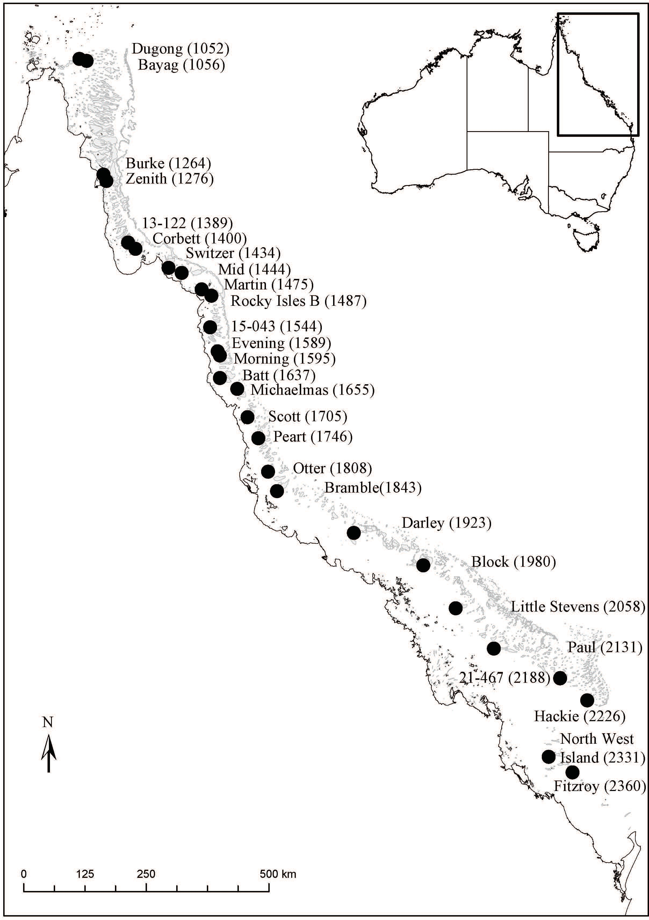

**Fig. 4.1** Location of the 27 survey reefs along the Great Barrier Reef. One to three sites were surveyed per reef.

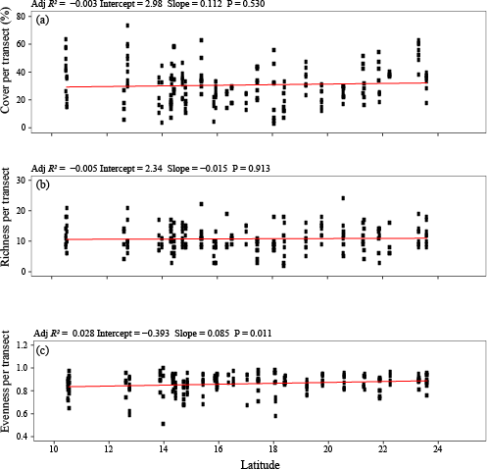

**Fig. 4.2** Changes in (a) reef-building coral cover, (b) species richness, and (c) evenness along the latitude of the Great Barrier Reef. Block dots represent the value of each index recorded on each transect. Red line and the formula above each graph represent the linear regression line and regression result.

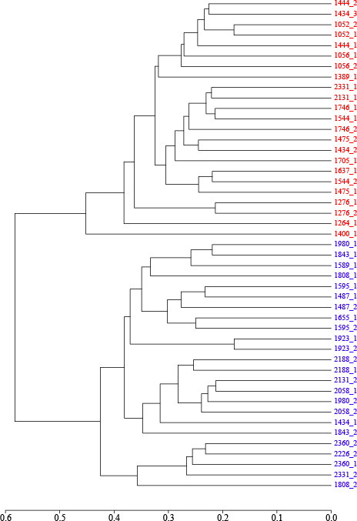

**Fig. 4.3** Hierarchical cluster analyses of coral assemblage composition on 47 sites of 27 reefs. The first four digits label the reef on the map, while the last digit refers to the site on each reef. The colours show the two groups identified in the cluster analysis.

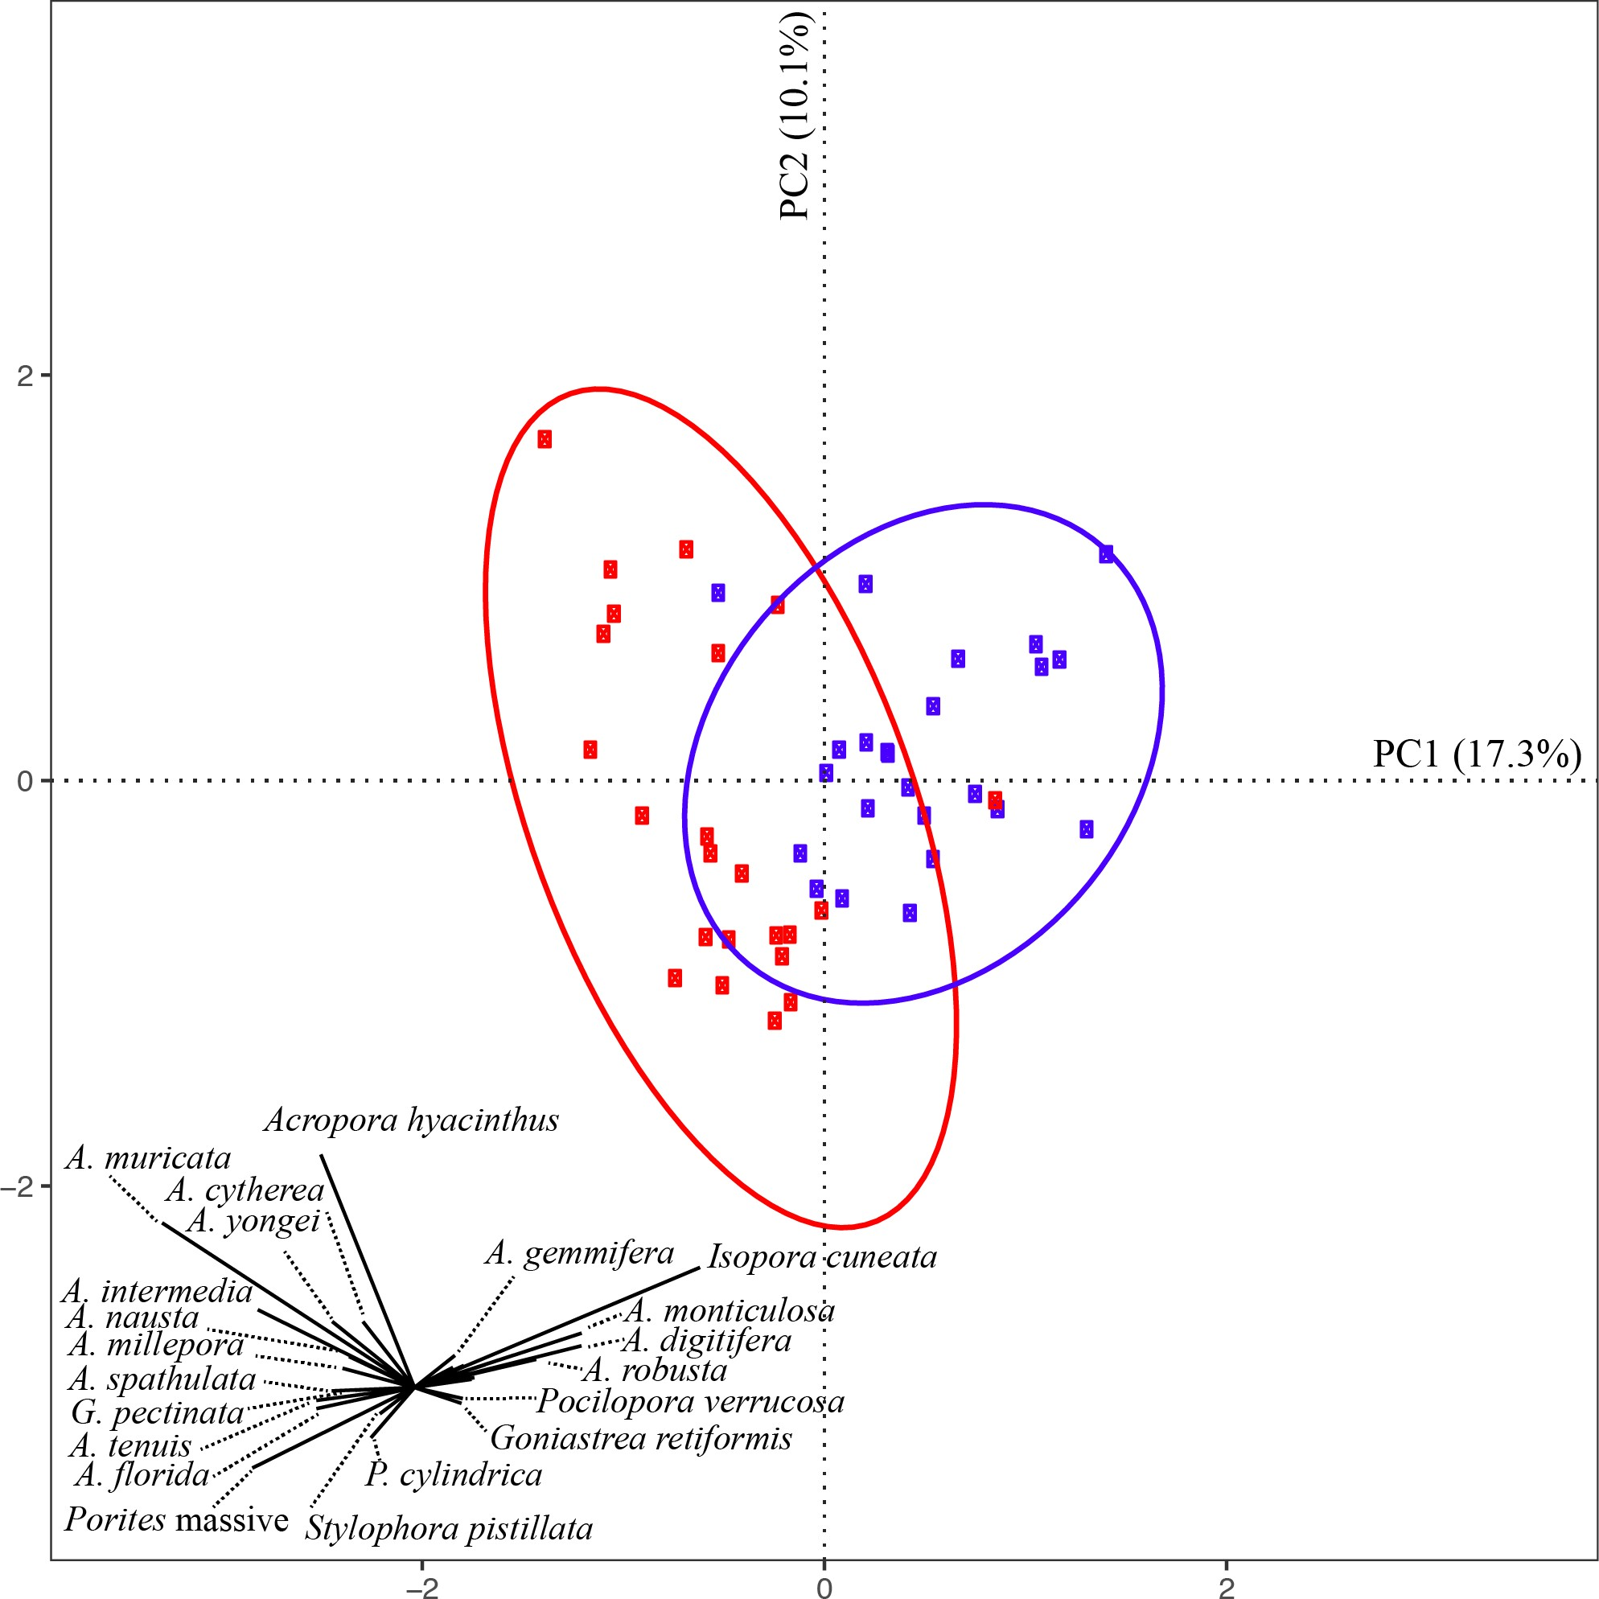

**Fig. 4.4** The principle component analysis (PCA) of coral assemblage composition on 47 sites of 27 reefs. The colours show the two groups identified in the cluster analysis.

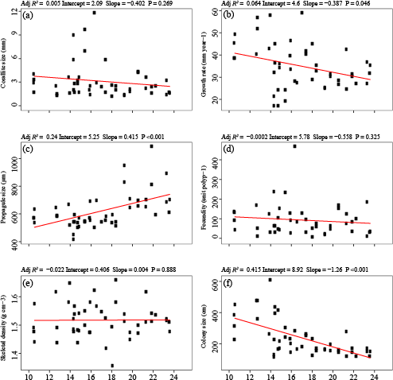

**Fig. 4.5** Assemblage-weighted means (AWM), block dots, in assemblages along the latitude for six species traits, including (a) corallite size, (b) growth rate, (c) propagule size, (d) fecundity, (e) skeletal density, and (f) colony size. The red line is the linear regression line.